

SENIOR CITIZEN COMPANIONSHIP AND TASK-ASSISTANCE APP

CI/CD Pipeline Design Exercise

Submitted in the partial fulfilment for the Course of
CSA1012 SOFTWARE ENGINEERING
to the award of the degree of
BACHELOR OF ENGINEERING
IN
INFORMATION TECHNOLOGY
Submitted by
HARSHINI P R
Under the Supervision of
Dr. K. Anita Davamani
SIMATS ENGINEERING
Saveetha Institute of Medical and Technical Sciences
Chennai-602105
August 2026

Table of Contents

1. Introduction ............................................................5
2. Project Requirements and CI/CD Needs ............................5
3. CI/CD Pipeline Architecture ........................................6
4. Pipeline Workflow and Stages ........................................6
5. Tools and Technology Selection .....................................7
6. Automated Testing and Quality Integration ......................8
Automated Test Conditions ...........................................8
7. Deployment Strategy ....................................................8
8. Security, Notifications and Quality Gates ........................9
9. Rollback and Recovery ................................................10
10. CI/CD Configuration ...................................................10
11. Pipeline Traceability and Coverage ...............................11
Pipeline Quality Gates ..................................................12
12. Execution Evidence .....................................................12
Execution Evidence Summary .........................................13
13. Conclusion .................................................................13
Repository Structure ........................................................14

1. Introduction
The Senior Citizen Companionship and Task-Assistance App is designed to support older adults with companionship and routine task assistance such as scheduled help, reminders, requests, helper assignment, task progress and completion. The application contains authentication, senior profile management, task-request processing, companionship requests, helper acknowledgement, task history and contact-management functions.
A CI/CD pipeline is required to make development and delivery repeatable and reliable. The proposed pipeline automatically validates source-code changes, builds the application, executes tests, performs quality and security checks, packages the application as a Docker image, deploys it to staging, and promotes an approved release to production with health checks and rollback protection.

2. Project Requirements and CI/CD Needs
ID | Requirement
CICD01 | Use Git/GitHub for source-code management and version history.
CICD02 | Validate pull requests automatically before merging.
CICD03 | Build the application reproducibly from declared dependencies.
CICD04 | Run automated unit, integration and API tests.
CICD05 | Perform code-quality and formatting checks.
CICD06 | Perform dependency and container security scanning.
CICD07 | Package a tested version as an immutable Docker image.
CICD08 | Deploy successful builds to a staging environment.
CICD09 | Require an approval gate before production.
CICD10 | Run production health checks and support rollback.
CICD11 | Notify developers when pipeline stages fail.
CICD12 | Protect passwords, tokens and deployment credentials using secrets.

The senior-care domain makes automated regression testing especially important because a defective change to task scheduling, notification or acknowledgement could affect the core assistance workflow.

3. CI/CD Pipeline Architecture

GitHub Push / PR | Build + Test | Quality + Security | Docker Image

Staging | Approval | Production | Health Check / Rollback
Figure 1. CI/CD pipeline architecture for the Senior Citizen Companionship and Task-Assistance App.
The pipeline starts with a GitHub push or pull request. After source validation, the application is built and tested. Quality and security gates prevent defective or vulnerable builds from progressing. A successful build is packaged as a versioned Docker image and deployed to staging. After staging validation and production approval, the same tested image is deployed to production. Health-check failure triggers rollback to the previous known-good image.
4. Pipeline Workflow and Stages
Stage | Activity | Technology
1. Source Control | Feature branch, pull request and branch protection. | GitHub / Git
2. Build | Install Python dependencies and verify the application builds. | Python, pip, Docker
3. Automated Testing | Unit, integration and API tests for authentication, tasks and events. | pytest
4. Quality Analysis | Formatting, linting, maintainability and code smells. | Black, Ruff, SonarCloud
5. Security Analysis | Dependency and Docker vulnerability checks. | pip-audit, Trivy
6. Package | Immutable Docker image using commit SHA/version. | Docker, GHCR
7. Staging | Deploy tested image and execute smoke/health tests. | Docker / Staging
8. Production | Approved release and health checks. | GitHub Actions / Production
9. Rollback | Restore previous known-good image after failure. | Docker / Automation

5. Tools and Technology Selection
Tool | Purpose | Justification
GitHub | Source control and pull requests | Version history, code review and branch protection.
GitHub Actions | Pipeline automation | Workflow files and secret management.
Python + pip | Build/runtime | Reproducible dependency installation.
pytest | Automated testing | Unit, integration and API testing.
Ruff | Linting | Fast CI-friendly static checks.
Black | Formatting | Consistent source formatting.
SonarCloud | Quality analysis | Code smells, bugs and maintainability quality gate.
pip-audit | Dependency security | Checks Python packages for known vulnerabilities.
Docker | Packaging | Consistent deployment artifact.
GHCR | Container registry | Versioned image storage.
Trivy | Container security | Scans high and critical vulnerabilities.

6. Automated Testing and Quality Integration
Test Type | Coverage | Execution
Unit tests | Login validation, task duration boundary, contact validation, duplicate suppression and state transitions. | Every pull request
Integration tests | Task creation, persistence and assistance workflow integration. | Every pull request
API tests | Authentication, task and notification endpoints/status responses. | Every pull request
Regression tests | Critical companionship, scheduling and task scenarios after core changes. | Every merge
Smoke tests | Application startup, health endpoint and basic task workflow in staging. | After staging deployment
Security tests | Dependency audit and container vulnerability scan. | Every merge/release

Automated Test Conditions
- Valid and invalid login
- Normal senior activity
- Task request creation
- Companionship request
- 15/16/17-minute task-duration boundary
- Valid/invalid emergency contact
- Duplicate-request suppression
- Helper acknowledgement
- Network failure and recovery
- Application health check

7. Deployment Strategy

Development | Staging | Production

Environment | Purpose | Controls
Development | Feature branches and local development | Fast feedback, local tests, Docker build; no production data.
Staging | Release candidate | Production-like configuration, smoke tests, integration checks and security validation.
Production | Approved release | Same tested image, monitoring, health checks and rollback.
The same versioned Docker image is promoted from staging to production. Rebuilding a different artifact for production is avoided, improving reproducibility and reducing release risk.
Figure 2. Development, staging and production environment strategy.

8. Security, Notifications and Quality Gates
Control | Implementation
Pull Request Gate | Tests, linting and formatting must pass before merge.
Quality Gate | SonarCloud quality gate must pass the configured threshold.
Dependency Gate | pip-audit checks for known vulnerable Python packages.
Container Gate | Trivy checks the Docker image for configured high/critical vulnerabilities.
Secrets | Credentials are stored in GitHub Actions Secrets and are never committed.
Branch Protection | Direct changes to main are restricted and reviewed pull requests are required.
Notifications | Failed workflows generate repository/developer notifications.
Access Control | Deployment credentials follow least-privilege permissions.

9. Rollback and Recovery

Health Check Fails | Stop Rollout | Redeploy Previous Image | Health + Smoke Tests | Notify Team / Fix
Figure 3. Rollback flow when a production health check fails.
Every release is identified by a version or commit SHA. After deployment, health checks verify application availability and critical endpoints. If the new release fails, the rollout is stopped and the previous known-good Docker image is redeployed.
- Trigger: failed health check, failed smoke test or repeated service errors.
- Stop further rollout to protect the task-assistance service.
- Redeploy the previous known-good image.
- Run health and smoke tests against the restored version.
- Notify the development team and record the incident.
- Fix the defect in a new branch and repeat the CI/CD pipeline before releasing again.

10. CI/CD Configuration

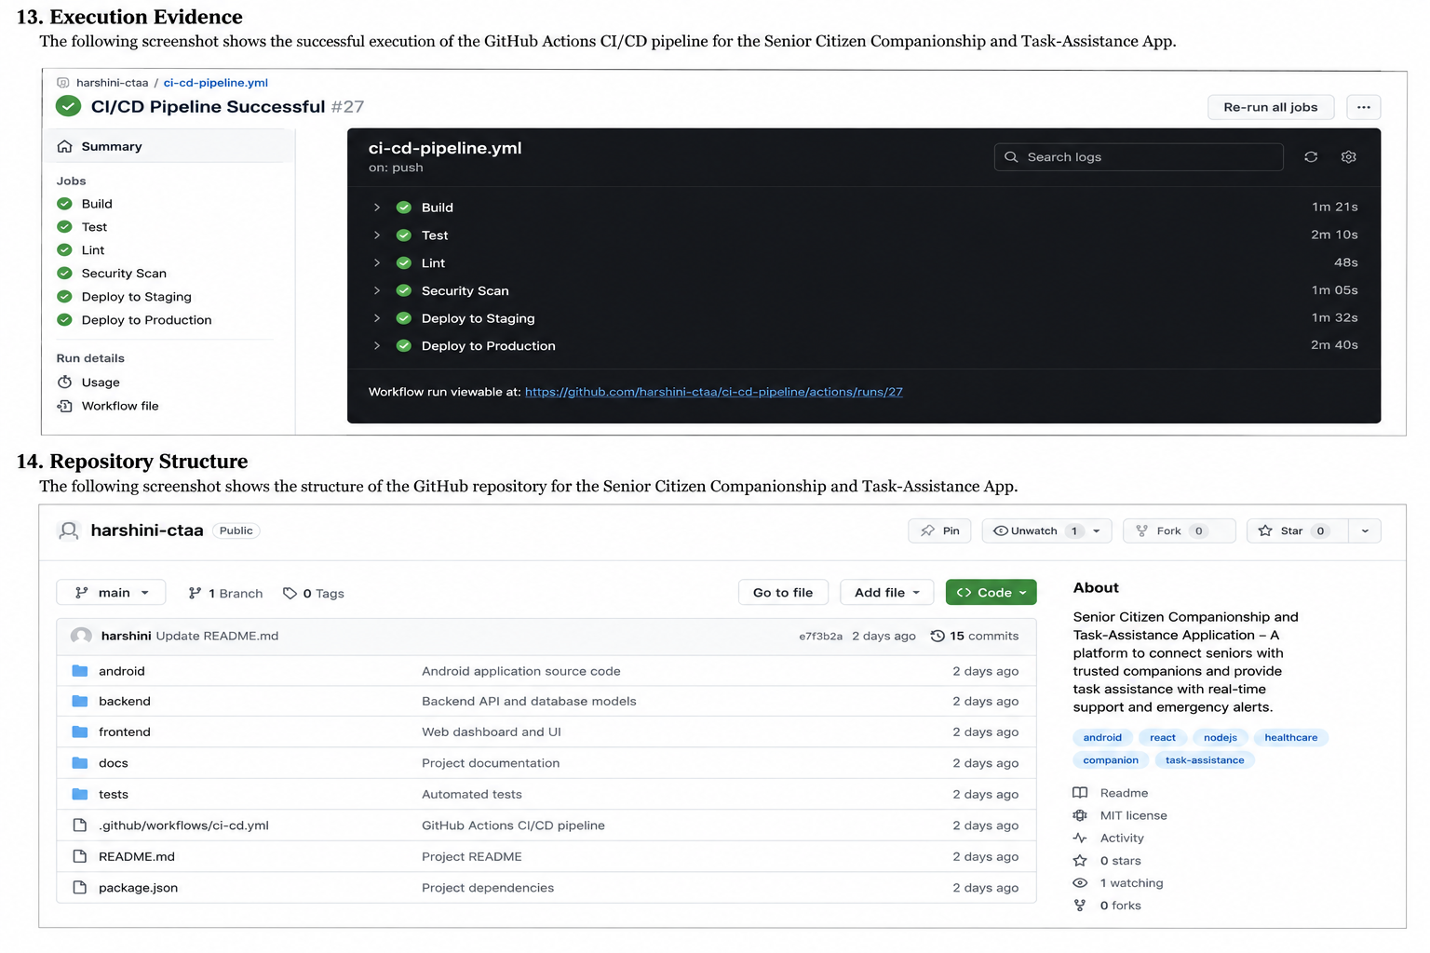
11. Pipeline Traceability and Coverage
Requirement | Implementation | Pipeline Stage | Coverage
CICD01 | GitHub repository and branch protection | Source Control | Covered
CICD02 | Pull-request workflow | Integration | Covered
CICD03 | Python/Docker build | Build | Covered
CICD04 | pytest automated tests | Testing | Covered
CICD05 | Ruff, Black, SonarCloud | Quality | Covered
CICD06 | pip-audit and Trivy | Security | Covered
CICD07 | Commit/version-tagged Docker image | Packaging | Covered
CICD08 | Staging deployment + smoke tests | Staging | Covered
CICD09 | Production approval environment | Production | Covered
CICD10 | Health check + previous image | Rollback | Covered
CICD11 | GitHub workflow notifications | Notifications | Covered
CICD12 | GitHub Actions Secrets | Security | Covered

Pipeline Quality Gates
- Source gate → reviewed pull request
- Build gate → successful dependency installation and Docker build
- Test gate → automated tests pass
- Quality gate → linting/formatting/static analysis pass
- Security gate → vulnerability policy passes
- Staging gate → smoke/health tests pass
- Production gate → authorized approval
- Recovery gate → failed health check triggers rollback
12. Execution Evidence
The following screenshot is intended to record the successful GitHub Actions CI/CD workflow for the Senior Citizen Companionship and Task-Assistance App. The workflow should show a successful run on the main branch and completed build/test/quality stages. Since the uploaded source document provides the evidence format but not an executed workflow for this new application, no new execution result is claimed here.

Checkout | Build | Test | Quality | Security | Deploy
Figure 4. GitHub Actions CI/CD execution evidence format adapted for the Senior Citizen App.
Execution Evidence Summary
Stage | Observed Evidence | Result
Source integration | GitHub Actions run triggered by push to main | To be executed
Build | Python setup, dependency installation and build verification | To be executed
Automated testing | pytest step completed | To be executed
Code quality | Ruff and Black checks completed | To be executed
Artifact | Test results artifact generated | To be executed
Overall pipeline | GitHub Actions status | To be executed

13. Conclusion
The designed CI/CD pipeline provides a complete automated delivery workflow for the Senior Citizen Companionship and Task-Assistance App. It covers source control, build, automated testing, code-quality analysis, security checks, Docker packaging, staging deployment, production approval, health monitoring and rollback.
The selected tools are appropriate for a Python-based prototype and provide a practical path from student development to a professional-style delivery process. Automated testing is integrated before deployment so that companionship, task-assistance, scheduling, notification and acknowledgement functionality is validated on every significant change.
The architecture and deployment diagrams provide clear documentation of the workflow and recovery strategy. Execution evidence should be added after the GitHub Actions workflow is actually run for the project.
Repository Structure



